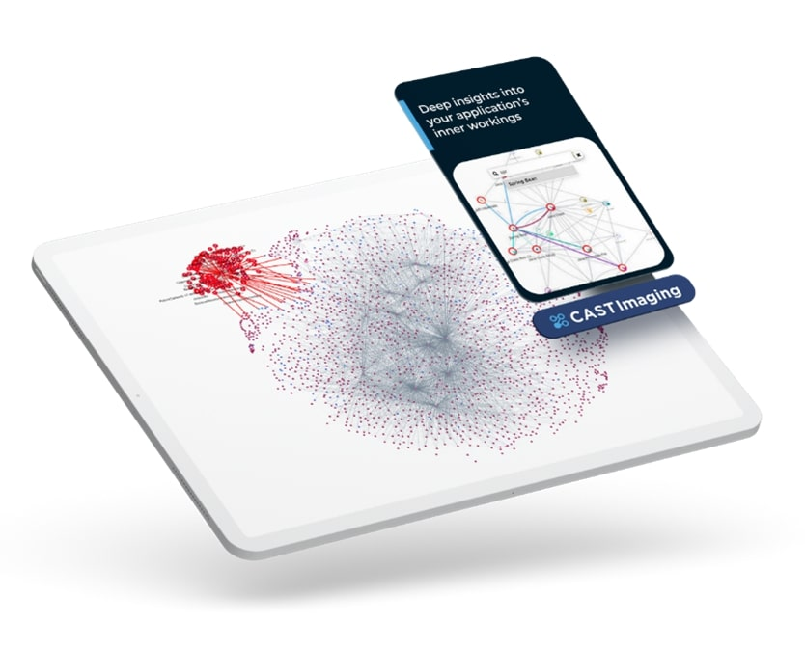

**CAST IMAGING**

**RecipePortal**

APPLICATION DISCOVERY REPORT

Report Date: 21/03/2025

TABLE OF CONTENTS

* APPLICATION SUMMARY
* ARCHITECTURE - TECHNOLOGIES
* DATABASE – DATA ACCESS
* DATABASE – DATABASE STORAGE

APPLICATION SUMMARY

**Summary of the application.**

|  |  |
| --- | --- |
| **Property** | **Value** |
| Lines of code | 72168 |
| Number Of Objects | 7491 |
| Number Of Relationships | 25325 |

ARCHITECTURE - TECHNOLOGIES

**Technology level represents all the identified technology object types in the application.**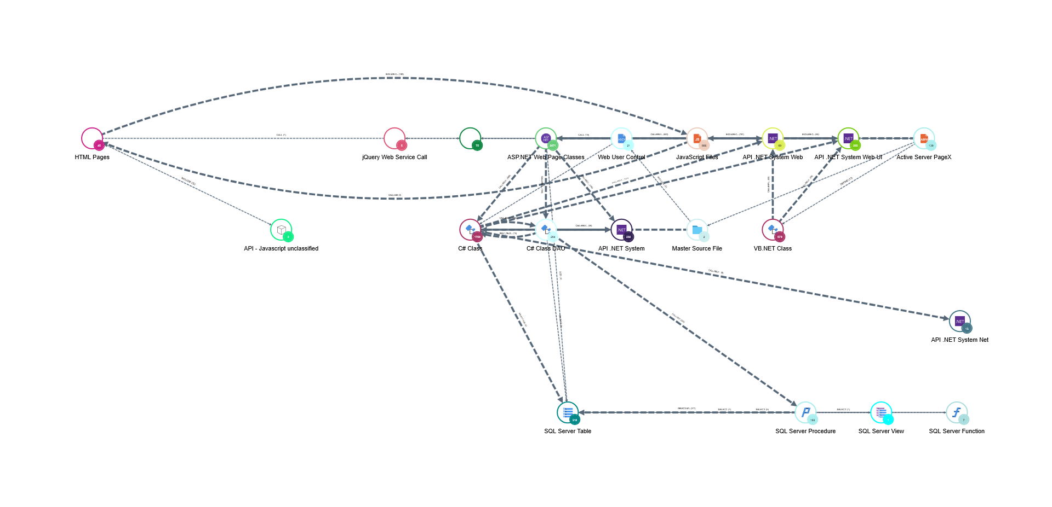

|  |  |  |  |
| --- | --- | --- | --- |
| **Object Types** | **Callee Object Types** | **Links** | **Grouped Objects** |
| API .NET System Web |  | READ(1)  WRITE(1)  GET(3)  SET(2)  CALL(3)  RELY_ON(2)  IMPLEMENT(2) | 69 |
| ASP.NET Web Page Classes | C# Class DAO  SQL Server Table  API .NET System Web  API .NET System Web UI  API .NET System  C# Class | EXTEND(1)  WRITE(1)  INCLUDE(1)  USE(1)  INSTANTIATE(1)  CALL(6)  IMPLEMENT(1)  READ(4)  OVERRIDE(1)  DEFINE(2)  RELY_ON(5)  GET(5)  SET(4) | 2671 |
| C# Class | API .NET System Web  API .NET System Net  API .NET System Web UI  API .NET System  C# Class DAO  SQL Server Table | CALL(6)  RELY_ON(7)  READ(4)  IMPLEMENT(2)  OVERRIDE(1)  INSTANTIATE(1)  USE(1)  WRITE(1)  GET(6)  SET(5)  EXTEND(1)  DEFINE(3)  INCLUDE(1)  SELECT(1) | 1768 |
| VB.NET Class | API .NET System Web  API .NET System Web UI | CALL(2)  IMPLEMENT(1)  GET(2)  RELY_ON(1)  EXTEND(1)  SET(1)  DEFINE(1) | 579 |
| API .NET System Net |  | RELY_ON(1)  READ(1)  SET(1)  CALL(1) | 13 |
| API - Javascript unclassified |  | INCLUDE(1) | 2 |
| HTML Pages | API - Javascript unclassified  JavaScript Files  Javascript Web Service Call | CALL(3)  USE(1)  INCLUDE(2) | 45 |
| API .NET System Web UI |  | CALL(3)  RELY_ON(3)  EXTEND(3)  IMPLEMENT(1)  READ(2)  WRITE(1)  OVERRIDE(2)  GET(3)  SET(3) | 262 |
| jQuery Web Service Call |  | CALL(1) | 5 |
| JavaScript Files | jQuery Web Service Call  HTML Pages  Javascript Web Service Call | CALL(5)  INCLUDE(2)  USE(1) | 806 |
| API .NET System |  | CALL(3)  RELY_ON(3)  IMPLEMENT(1)  READ(3)  GET(3)  SET(3) | 236 |
| C# Class DAO | API .NET System  C# Class  SQL Server Procedure  SQL Server Table | GET(5)  SET(1)  SELECT(1)  CALL(4)  RELY_ON(4)  READ(1) | 204 |
| Active Server PageX | ASP.NET Web Page Classes  JavaScript Files  Master Source File  Web User Control  Javascript Web Service Call  VB.NET Class | DEFINE(2)  INCLUDE(4)  CALL(3) | 139 |
| SQL Server Table |  | USE(2)  SELECT(5)  UPDATE(1)  INSERT(1)  DELETE(1) | 218 |
| Master Source File | C# Class  Web User Control | INCLUDE(3)  DEFINE(1) | 2 |
| Web User Control | C# Class | INCLUDE(2)  DEFINE(1) | 21 |
| Javascript Web Service Call |  | CALL(3) | 75 |
| SQL Server Procedure | SQL Server Function  SQL Server Table  SQL Server View | CALL(2)  GET(1)  SELECT(2)  UPDATE(1)  INSERT(1)  DELETE(1) | 193 |
| SQL Server Function | SQL Server Table | CALL(1)  SELECT(1) | 7 |
| SQL Server View | SQL Server Table | SELECT(2) | 1 |

DATABASE – DATA ACCESS

**Represents database interactions for the application that helps to understand different application objects accessing the database.**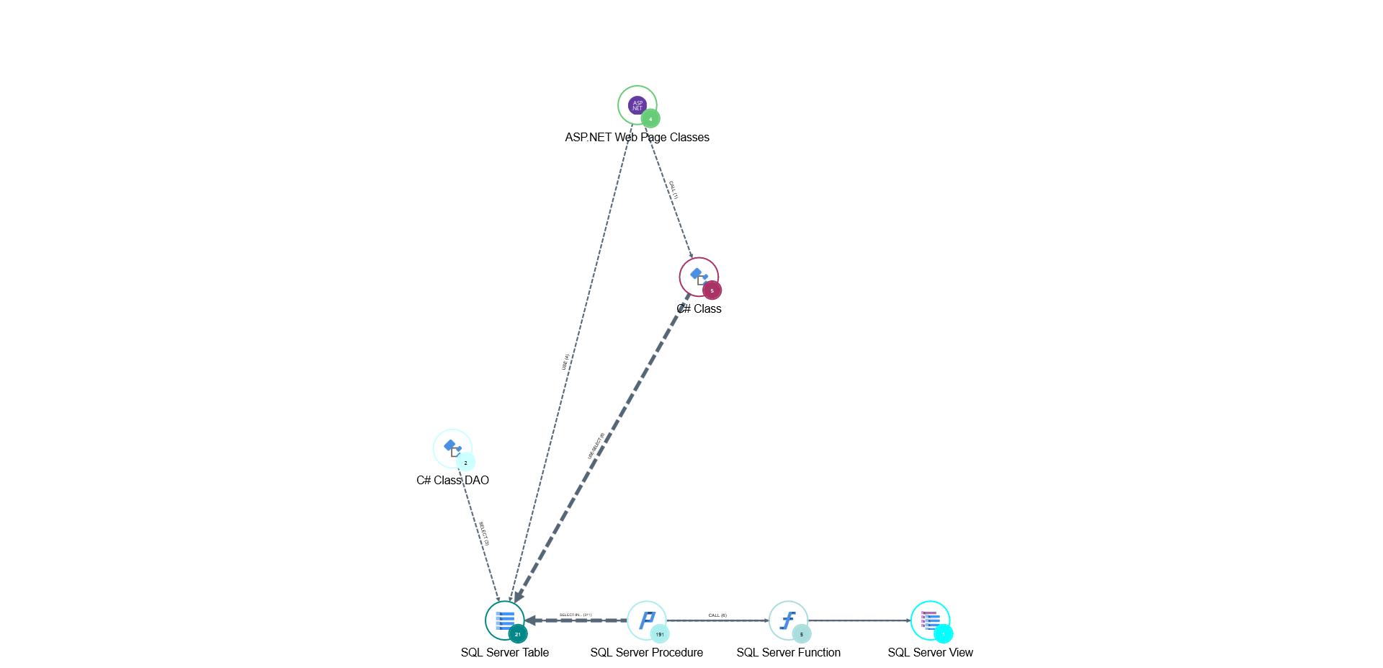

|  |  |  |  |
| --- | --- | --- | --- |
| **Object Types** | **Callee Object Types** | **Links** | **Grouped Objects** |
| SQL Server View | SQL Server Table | SELECT(2) | 1 |
| SQL Server Table |  | SELECT(5)  INSERT(1)  DELETE(1)  UPDATE(1)  USE(2) | 21 |
| SQL Server Procedure | SQL Server View  SQL Server Table  SQL Server Function | SELECT(2)  INSERT(1)  DELETE(1)  UPDATE(1)  CALL(1) | 191 |
| SQL Server Function | SQL Server Table | SELECT(1)  CALL(1) | 5 |
| ASP.NET Web Page Classes | SQL Server Table  C# Class | USE(1)  CALL(1) | 4 |
| C# Class | SQL Server Table | CALL(1)  USE(1)  SELECT(1) | 5 |
| C# Class DAO | SQL Server Table | SELECT(1) | 2 |

DATABASE – DATABASE STORAGE

**Represents all the identified tables and their references to other tables.**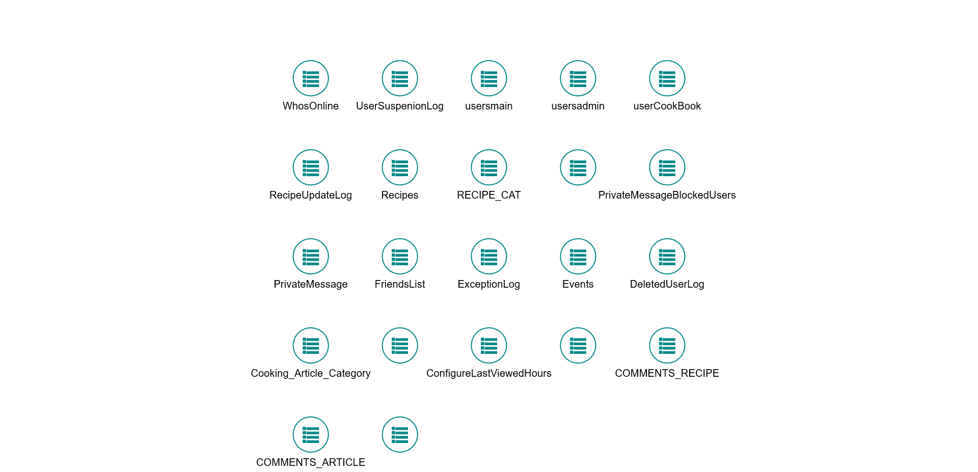

|  |  |  |  |
| --- | --- | --- | --- |
| **Object Types** | **Callee Object Types** | **Links** | **Grouped Objects** |
| WhosOnline |  |  | 7 |
| UserSuspenionLog |  |  | 6 |
| usersmain |  |  | 37 |
| usersadmin |  |  | 7 |
| userCookBook |  |  | 7 |
| RecipeUpdateLog |  |  | 5 |
| Recipes |  |  | 19 |
| RECIPE_CAT |  |  | 4 |
| PrivateMessageSentMessages |  |  | 10 |
| PrivateMessageBlockedUsers |  |  | 5 |
| PrivateMessage |  |  | 11 |
| FriendsList |  |  | 6 |
| ExceptionLog |  |  | 5 |
| Events |  |  | 12 |
| DeletedUserLog |  |  | 6 |
| Cooking_Article_Category |  |  | 3 |
| Cooking_Article |  |  | 16 |
| ConfigureLastViewedHours |  |  | 1 |
| Configuration |  |  | 7 |
| COMMENTS_RECIPE |  |  | 9 |
| COMMENTS_ARTICLE |  |  | 8 |
| ArticleUpdateLog |  |  | 5 |